Test Plan 1: Locational Noise Readings - No beans\*

\*Using Fresnel Zone Plate lens

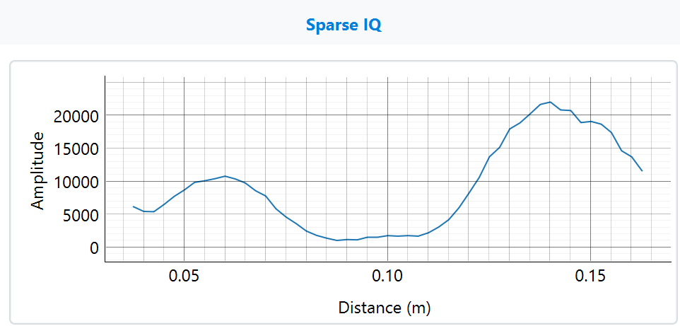

Figure 1: Balloon Lab - Black PETG

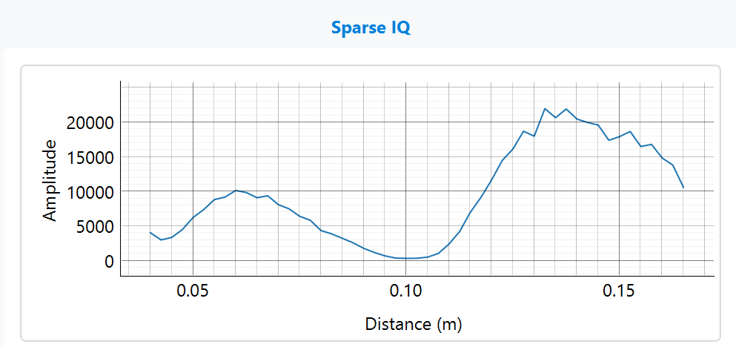

Figure 2: Balloon Lab - Orange PETG

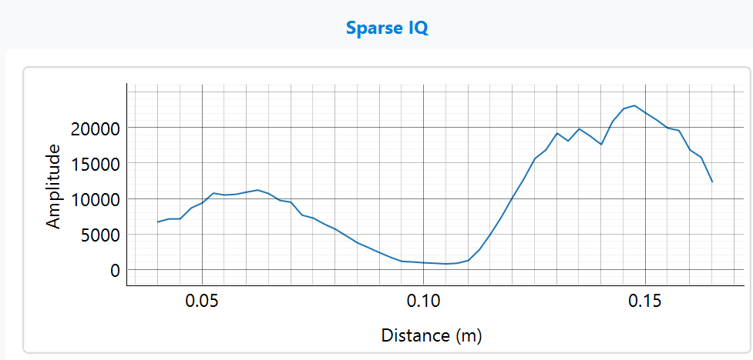

Figure 3: Tek Lab - Black PETG

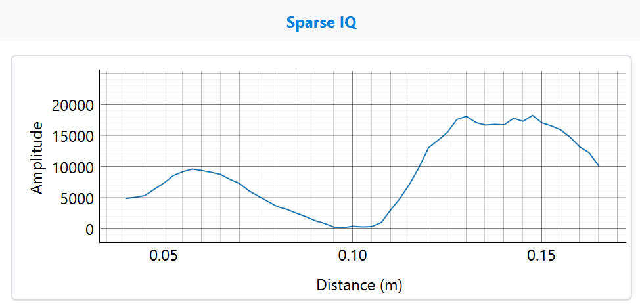

Figure 4: Tek Lab - Orange PETG

FZP (ridges up) D2:

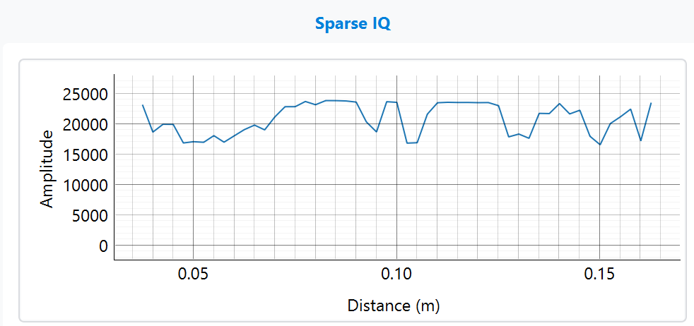

FZP (ridges up) D1:

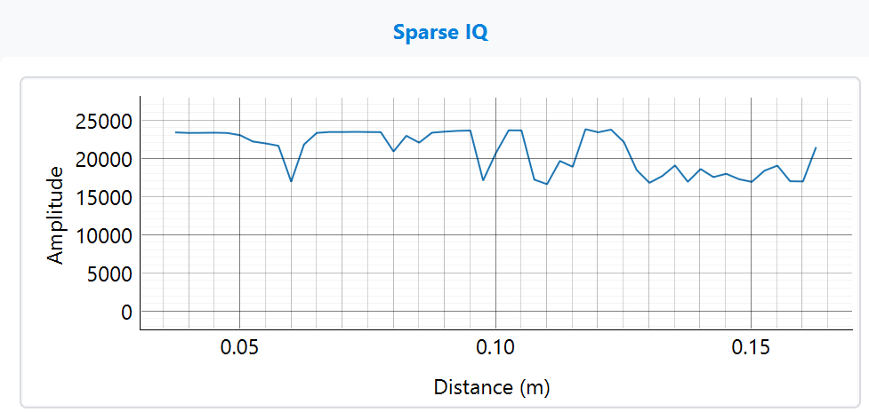

FZP (ridges down) D2:

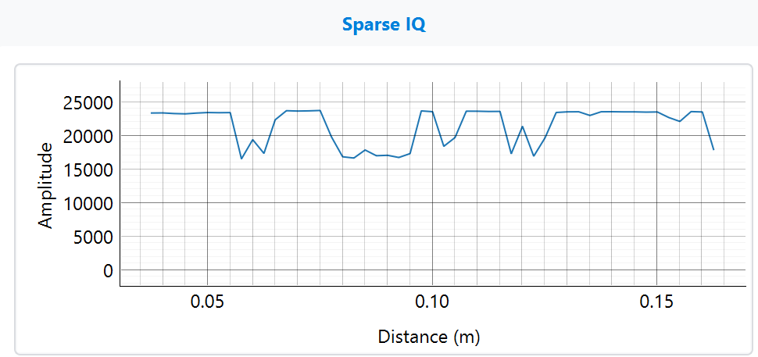

FZP (ridges down) D1:

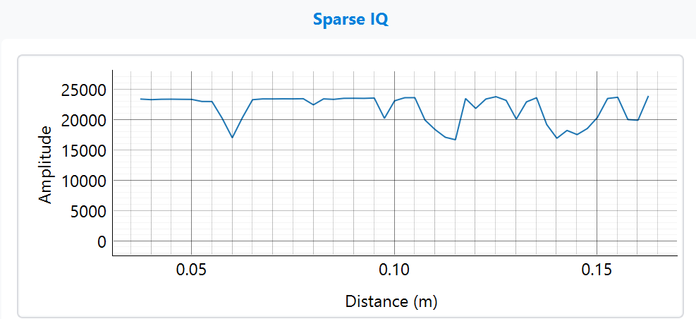

Parabolic D1:

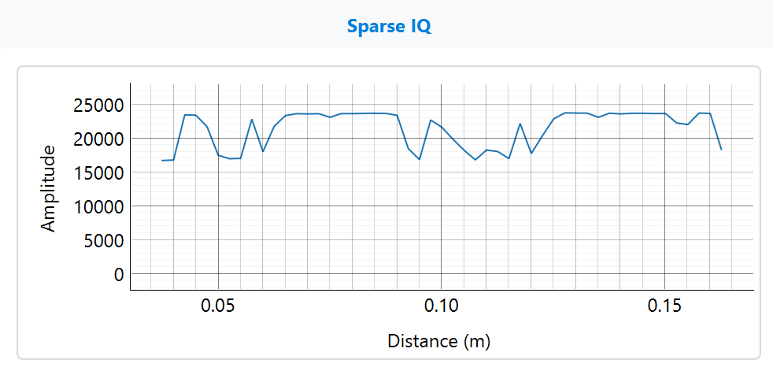

Parabolic D2:

